Jamberoo, Macquarie Pass and Kiama scenic drive
Head north to Kiama and then take Jamberoo Road to Jamberoo. From here, except for the odd detour to various attractions follow Jamberoo Mountain Road to Robertson and return on the Illawarra Highway via Macquarie Pass to Albion Park and, then the Princess Highway via Kiama, a sensational scenic drive. Some of the attractions include:
Jamberoo Village - whilst the hinterland is surrounded by dairy farmlands and green valleys, it is best known for its fabulous old pub and the Jamberoo Action Park, not suggesting you visit either.
Minnamurra Falls and Rainforest – Budderoo National Park - the falls is a beautiful two-tiered waterfall on the Minnamurra River, A scenic, moderately challenging walking track, starts from the Minnamurra Rainforest Centre, and can be combined with the Rainforest Loop walk. There is a chance to see wallabies and the whimsical lyrebird.
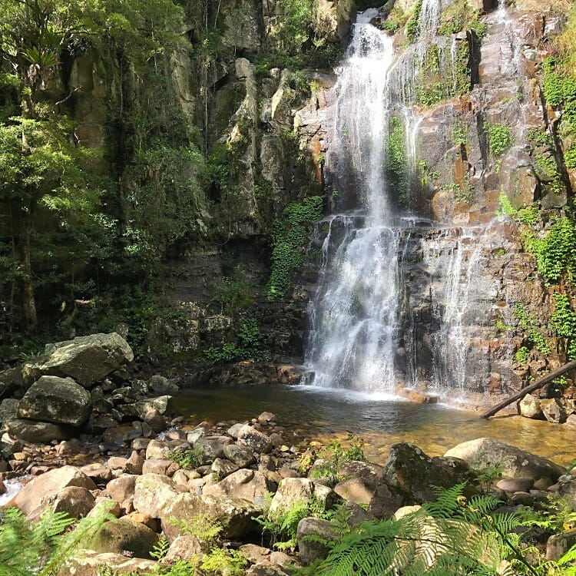 Minnamurra Falls
Carrington Falls – Budderoo National Park – With its cascades, waterholes and rock-pools, some regard Carrington Falls, where the Kangaroo River plunges over 50m to the gully below, as the most beautiful on the South Coast.
From the picnic area you’ll find a variety of walking tracks that take you to a series of lookouts fronting the magnificent falls. Be sure to take the short walk along Izzards lookout track to enjoy another spectacular view.
Illawarra Fly & Treetop Adventures - the only elevated steel walkway in NSW including Australia's highest zipline. Explore the temperate rainforest, waking the 1.5km tree walk. For one-third of the walk, you will be 30 metres above the ground, and the view from the lookout is breathtaking (10.00 to 5.00).
Robertson – famous for its pie shop and Big Potato – possibly the ugliest “big” thing in the country.

Then it’s down the picturesque Macquarie Pass along the Illawarra Highway and experience the beauty of the Illawarra escarpment.

Macquarie Pass National Park - experience the beauty of the Illawarra escarpment by taking a walk to the Cascades Falls, a hidden gem.

Albion Park - not today
Kiama – is known for the Kiama Blowhole and Little Blowhole, two cliff side caverns where seawater shoots into the air. The Kiama Coast Walk trail links the blowholes to the columns of Cathedral Rocks, with whale-watching spots along the way. Surf Beach has calm water for swimming.
Kiama’s town is full of charm, head to the National Trust-classified Historic Terrace Houses, built in 1886. There are many delightful shopping opportunities in Kiama, from galleries to emporiums to cultivated arts trail. You can also discover Kiama’s history at the Pilot’s Cottage Museum, in a lovingly restored home built in 1881.
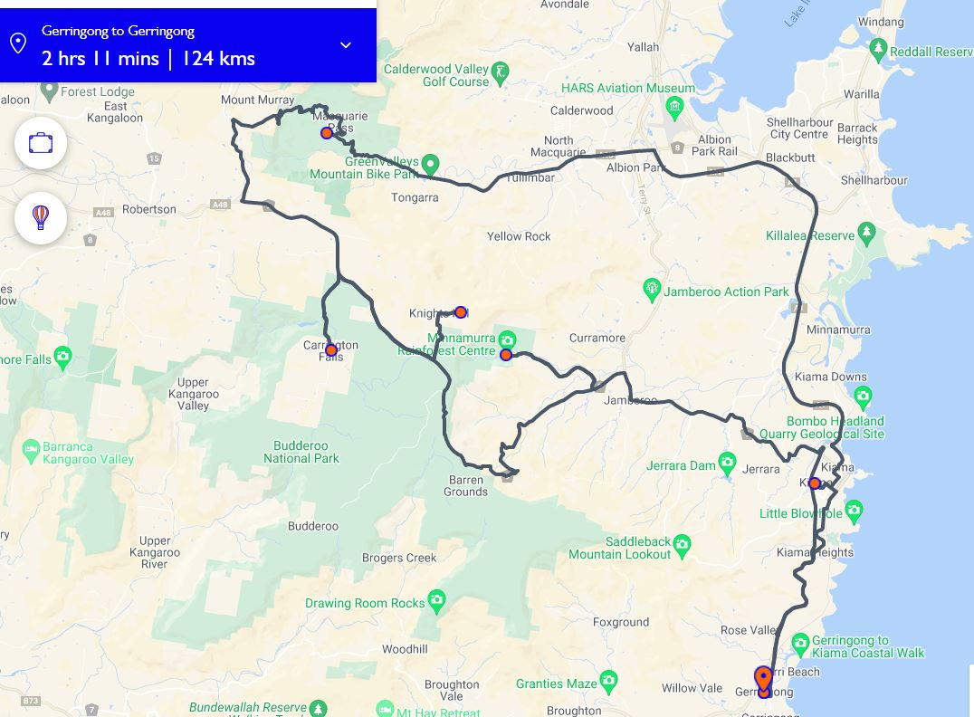
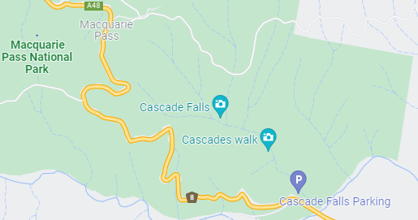
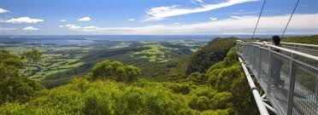
Illawarra Fly
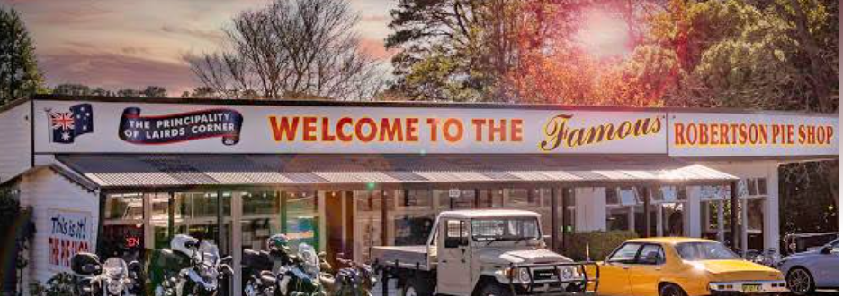
Guess?

