Berry, Kangaroo Valley & Shoalhaven Heads Scenic Drive
Berry - only 15 minutes south-west of our hotel (via Belinda Street and the Princess Highway) is this charming town. Its main street is lined with cute shops and its worth going for a wander, which should include the Ice Creamery and the Famous Berry Donut Van.
Then it’s Berry to Kangaroo Valley, this beautiful 26 km scenic drive, takes Kangaroo Valley Road out of Berry. The road winds up Berry Mountain through beautiful bush with glimpses of wonderful views over the surrounding countryside.
Once over the escarpment, the road winds down into the lush grasslands of Kangaroo Valley.
Kangaroo Valley - the scenery is gorgeous and the rolling green farmland backed by mountains makes even driving around the area a delight. The village has lots of atmospheric heritage buildings and there's a delicious treat to be had at almost every outlet.
The nearby Hampden Bridge, a Victorian suspension bridge with castle-like sandstone towers crosses over the Kangaroo River. The Pioneer Village Museum has displays on early settlers in 19th-century farm sheds.
After Kangaroo Valley take a short detour (refer map) to Cambewarra Mountain Lookout on Cambewarra Lookout Road, Beaumont.
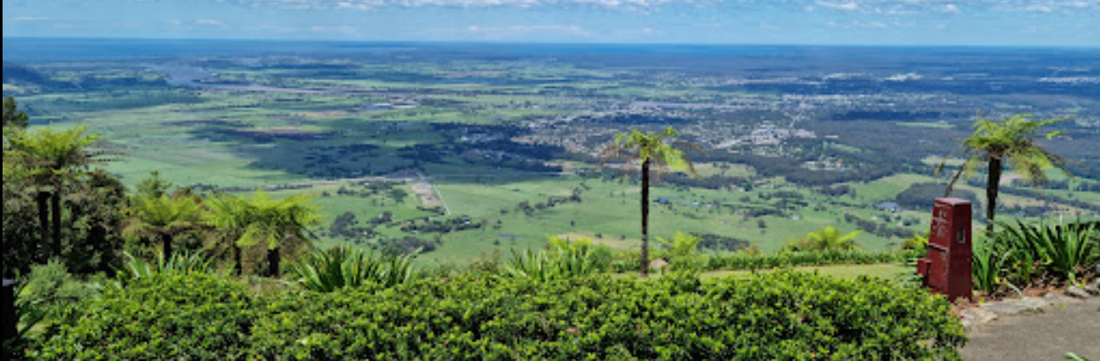
Cambewarra Mountain Lookout
Then it off to Shoalhaven Heads via Bomaderry or you could make a short detour into Nowra, why?
Shoalhaven Heads - has a fine surfing beach, access to the Shoalhaven River and is surrounded by wineries.
For example, the Coolangatta Estate at Coolangatta was established in 1822 and located on the northern bank of the Shoalhaven River, The estate today is in a picturesque setting overlooking the ocean and surrounded by vineyards.
Seven Mile Beach - is a national park and true to its name – offers over 12 kilometres of golden coastline. It consists of tidal flats, islands and a coastal sand barrier built from river silt in the Shoalhaven River delta. It is important areas for migratory waders and sea birds and protects a large littoral rainforest. There are great opportunities for bird watchers. They can observe king parrots, rainbow lorikeets, rosellas, wrens, New Holland honeyeaters and brown cuckoo doves.
Gerroa – this charming village is coastal living at its very best. Colourful houses dot the shoreline above the pretty beaches and sparkling blue ocean. Be sure to head up to Gerroa Headland if you’re visiting between May and November – migrating dolphins and whales are frequently spotted off shore.
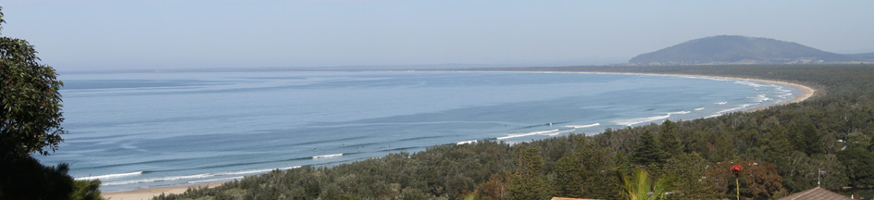
Seven Mile Beach

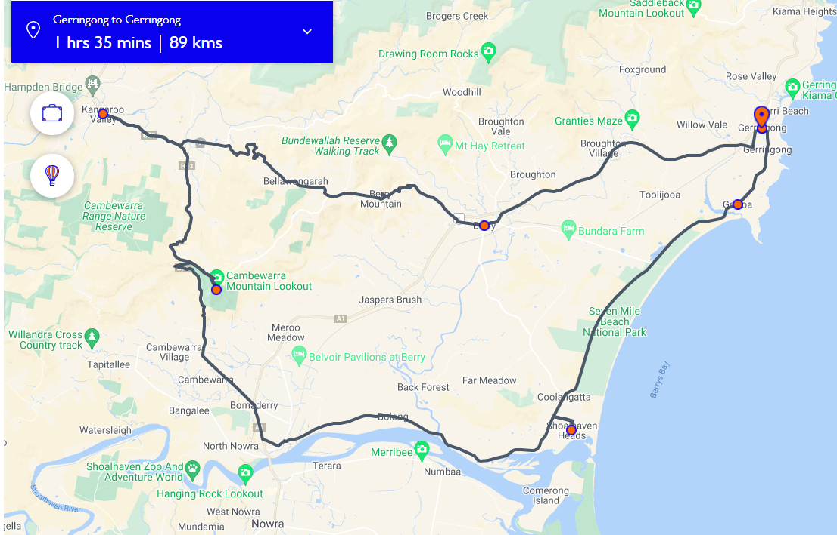

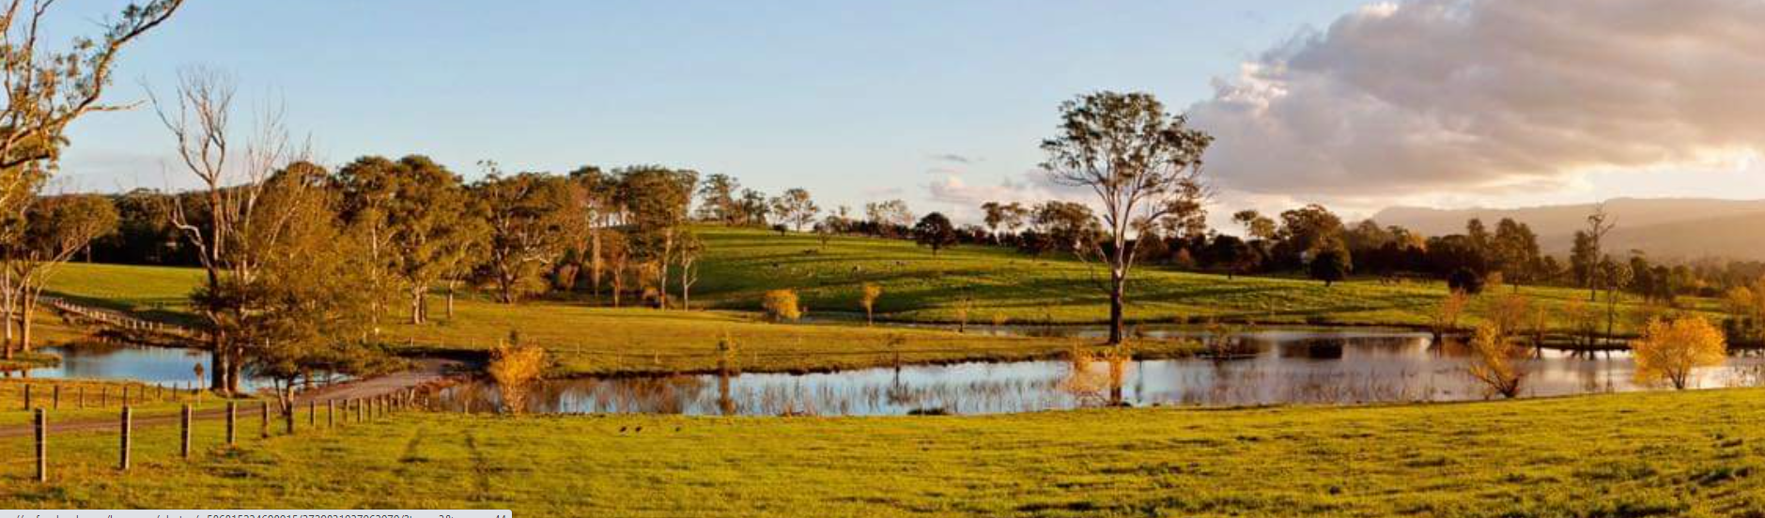
Berry South Coast

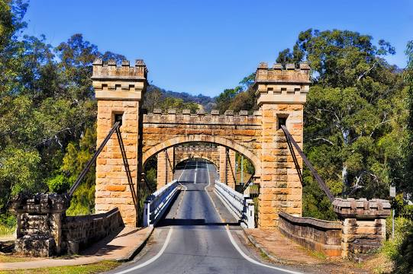
Hampton Bridge, Kangaroo Valley

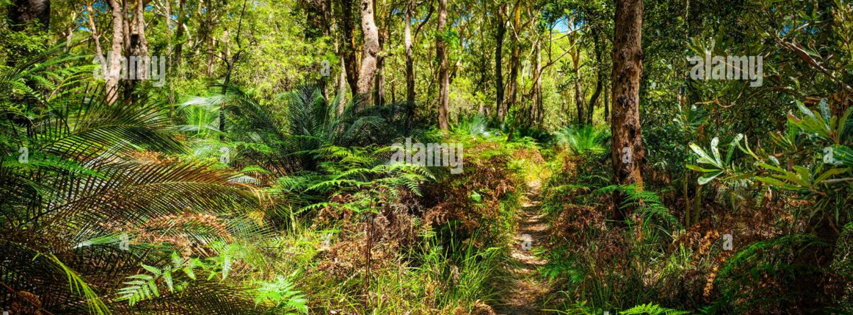
Bush walk, Seven Mile Beach

