Getting there, Sunday:
- Home to M7, Hume Hwy (M31) to Wilton, Picton Road to the Princess Hwy (M1) onto Albion Park and Gerringong (just off the map).

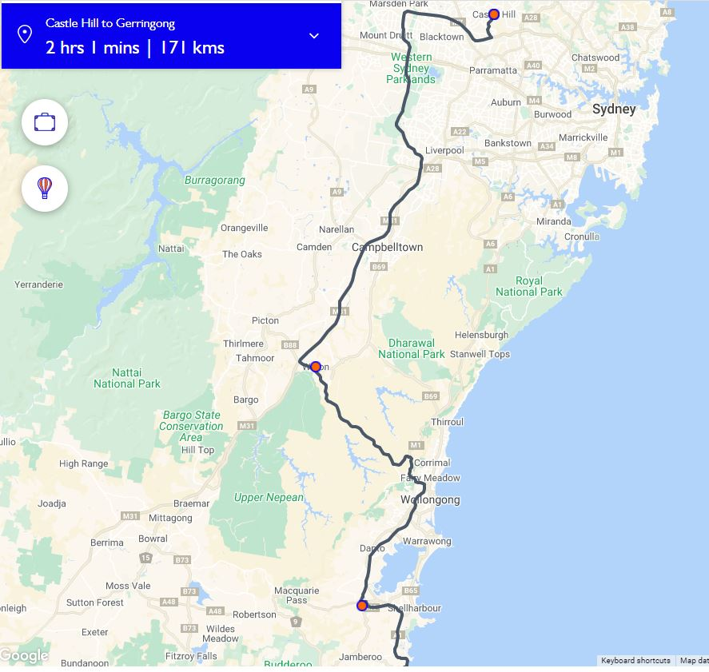
Attractions and detours:
- Albion Park - offers an abundance of history including the HARS Aviation Museum, located at Shellharbour Airport, providing the unique opportunity to access many aircraft and to see restorations in progress (9.30 to 3.30 seven days p.w.).

- Kiama – is known for the Kiama Blowhole and Little Blowhole, two cliff side caverns where seawater shoots into the air. The Kiama Coast Walk trail links the blowholes to the columns of Cathedral Rocks, with whale-watching spots along the way. Surf Beach has calm water for swimming.

Kiama’s town is full of charm, head to the National Trust-classified Historic Terrace Houses, built in 1886. There are many delightful shopping opportunities in Kiama, from galleries to emporiums to cultivated arts trail. You can also discover Kiama’s history at the Pilot’s Cottage Museum, in a lovingly restored home built in 1881.
- Gerringong - is a beautiful country town located in one of the richest dairy farming areas in NSW, about ten minutes south of Kiama. Its vibrant hilltop village is loaded with unique delights and browse-friendly stores, overlooking the arc of Werri Beach as it stretches between the two headlands. It’s here the you’ll find a contemporary collection of surf and seaside fashion, cafes and restaurants with seascape views, homewares, galleries, workshops and retreats.
Return trip, Wednesday:
- Princess Hwy (M1) to Heathcote, Heathcote Road to Lucas Heights, New Illawarra Road/ Alfords Point Road/Fairford Road/Rookwood Road to Auburn. Then St Hillers Road/ Silverwater Road and home.
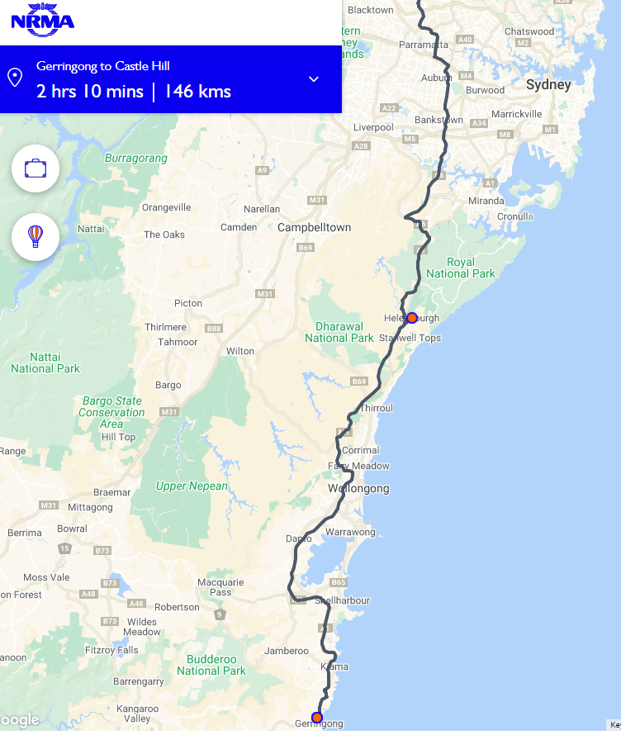
Attractions and detours:
- Kiama to Thirroul –the coastal route alternative (to the highway, hugging bird-rich Lake Illawarra.

- Thirroul to Stanwell Park –the drive includes charming seaside towns of Thirroul and Austinmer with postcard-perfect beaches. Bulli is a village that retains its colonial and mining heritage. Call into the cliff-side Scarborough Hotel, which opened in 1886 and offers ocean views you won’t believe (lunch option), or enjoy boutique shopping. Stanwell Park, an internationally acclaimed hang gliding spot, strap yourself in for a tandem ride soaring from the cliffs and over the sparkling ocean.

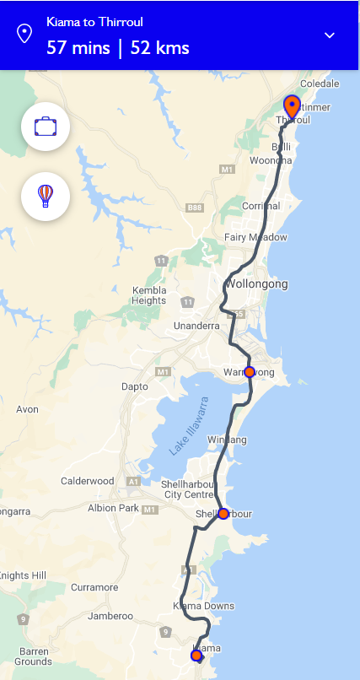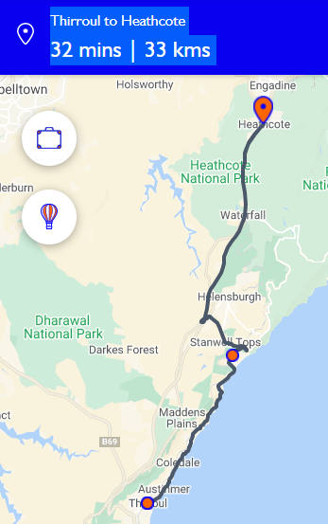
Photos next page:
- Kiama
- The 665 metre long Sea Cliff Bridge is a highlight along the Grand Pacific Drive.
- Stanwell Tops
